Literacy Plan

for

Livingston Parish Public Schools

Jody Purvis, Superintendent

Date
June 4, 2025

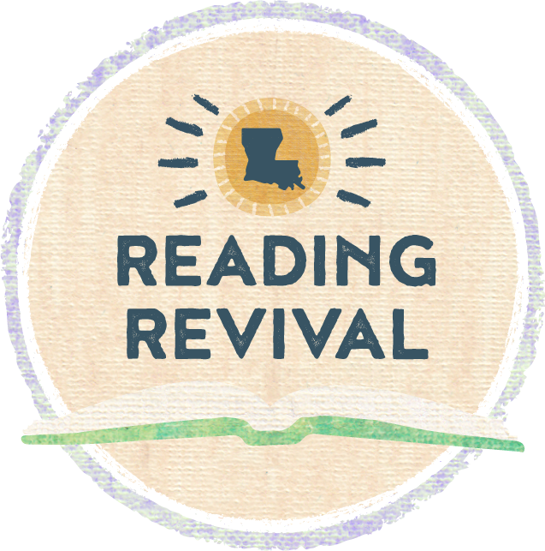

Section 1a: Literacy Vision and Mission Statement
Literacy Vision | In collaboration with families and communities, Livingston Parish Public Schools will enhance students' literacy outcomes by providing all students with high quality curriculum and instruction.
Literacy Mission Statement | Livingston Parish Public Schools is committed to providing students with a high-quality, enriching literacy foundation and skills to prepare them to successfully be college and career ready. Rigorous and relevant instruction in listening, speaking, reading, and writing is the focus of literacy learning in all content areas and classrooms.

Section 1b: Goals
Goal 1 (Student-Focused) | - By the end of the school year, K-3rd grade students will increase by 2.32% in literacy benchmarks.  - By the end of the school year, 3rd–5th grade students will demonstrate growth of 2.16% in ELA Mastery.  - By the end of the school year, 3rd–5th grade the number of students meeting their growth target will increase by 1.86%.
Goal 2 (Teacher-Focused) | - All teachers will demonstrate effective teaching practices that include meeting the individual needs of all students, implementing the Tier I curriculum with integrity measured by kickup walk throughs and LER observations. All teachers will use student data to effectively plan intervention/ extension instruction for all students including subpopulations as evidenced by DIBELS 8 end of year data, LEAP 2025, iReady Reading Diagnostic and progress monitoring assessments.  - All teachers will use student data from DIBELS 8, iReady Reading Diagnostic, Progress Monitoring and LEAP to monitor individual students' progress and adjust interventions and extensions as needed throughout the school year.
Goal 3 (Program-Focused) | - Livingston Parish Public Schools will implement the Literacy Program throughout the school year that includes the following: Tier 1 reading curriculum, support for all students using reading interventions and/or extensions based on literacy deficits and diagnostic assessments.  - Teacher effectiveness will be measured through Canopy Science of Reading training, observation with LER rubrics, Kickup walk through data analysis and monitoring of literacy data through ongoing collaboration and team meetings.

Section 1c: Literacy Team
District Literacy Support Members
Member | Role
Jody Purvis | Superintendent
Tracy McRae | Asst. Superintendent
Beth Jones | Director of Curriculum
Stacey Milton | Supervisor of Instruction
Shanna Steed | Supervisor of Instruction
Lynette Wheat | Supervisor of Instruction
Dwayne Dykes | Supervisor of Instruction
Lee Hawkins | Supervisor of Instruction
Nita Flores | Curriculum Coordinator
Julie Norris | Curriculum Coordinator
Vanessa Navarre | Curriculum Coordinator
Courtney Borland | Curriculum Coordinator
Jo Kay Tullos | Curriculum Coordinator
Tammy Kuhn | Title II Coordinator
Bonnie Cox | Director of Federal Programs
Monica Hanna | RTI Academic Interventionist
Hailey Franklin | 504/Dyslexia Coordinator

LPPS District Literacy Support Members will:
- Create, implement, and monitor the district literacy plan while setting and adjusting goals for ongoing literacy learning in schools.
- Participate in literacy meetings at the Central Office to discuss schools’ literacy goals, needs, and adjustments to ongoing literacy learning.
- Analyze BOY, MOY and EOY assessment data to adjust ongoing literacy learning to improve literacy outcomes (MyPerspectives, iReady Reading Diagnostic, DIBELS 8th data, phonics screeners, Phonological awareness screener, Teaching Strategies GOLD/SmartTeach)
- Analyze End of Unit and Module Assessment Data for Tier I curriculums to adjust ongoing literacy learning.
- Collaborate and review Action plan, check progress, and adjust for literacy learning goals.
- Support members visit schools after BOY, MOY, EOY assessments (DIBELS 8th, iReady Reading Diagnostic, MyPerspectives and HMH) and participate in monthly ILT and teacher collaboration meetings at schools to discuss ongoing literacy learning and provide guidance.
- District support members will assist schools in creating and adjusting intervention groups addressing the needs of all students including (Subgroups such as: EL, SPED, 504) using data from DIBELS 8th, iReady Reading Diagnostic, MyPerspectives, Phonological awareness screener s and Phonics screeners.
- ILT members provide professional learning opportunities for teachers and other personnel who provide intervention/ extension instruction.
- Collaborate with team members to determine effectiveness and adjust the Livingston Parish Literacy Plan initiative to meet all students’ needs.
Needs Assessment:
DIBELS 8th data demonstrates a need for the implementation of a strong Literacy Plan to improve intentional practices to meet the needs of our students by providing evidence-based reading instruction and intervention with strong monitoring and follow up. In 2023 – 2024 our students scoring below benchmark showed minimal improvement in First Grade and decline in Second and Third Grade.
2023 – 2024 DIBELS 8th Assessment | Beginning of Year Percentage Below Benchmark | Middle of Year Percentage Below Benchmark | End of Year Percentage Below Benchmark | Growth from Beginning of Year to End of Year
Kindergarten | 72% | 51% | 39% | 33%
1st Grade | 50% | 47% | 28% | 22%
2nd Grade | 43% | 44% | 34% | 9%
3rd Grade | 42% | 40% | 34% | 8%
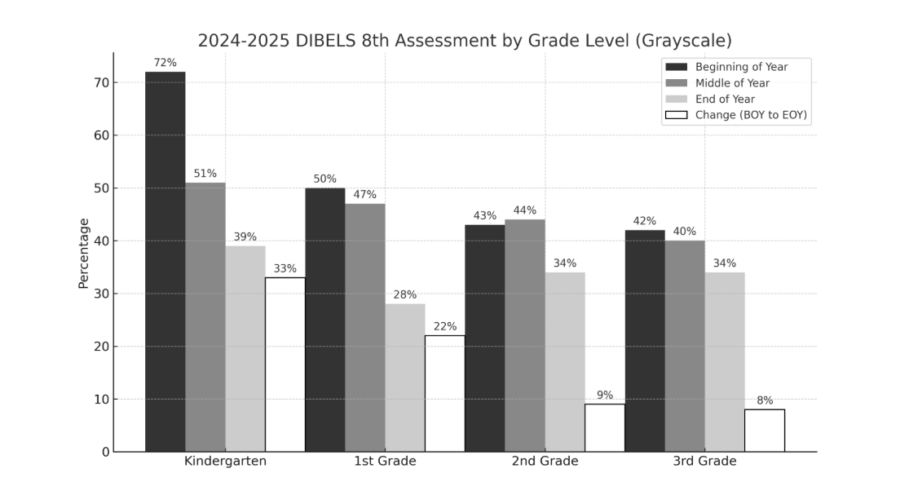

Teaching Strategies GOLD/SmartTeach data demonstrates the need for continued use of effective language and literacy practices to lower the percentage of children working below the widely held expectations by the spring checkpoint, therefore increasing the percentage of children meeting and exceeding them.

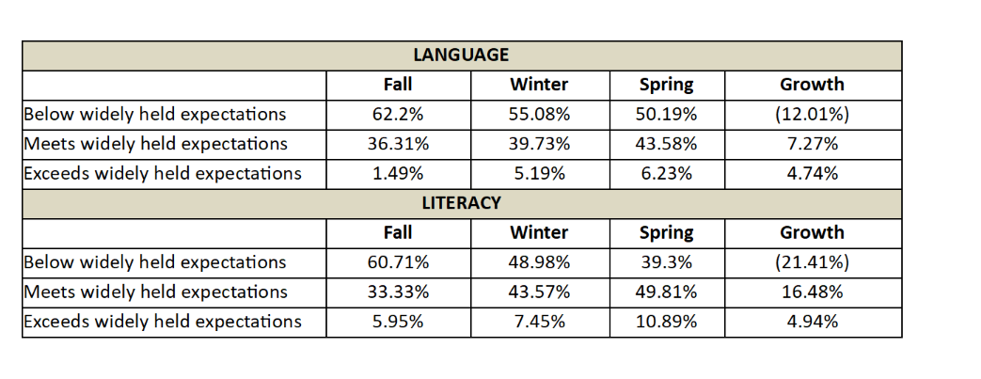

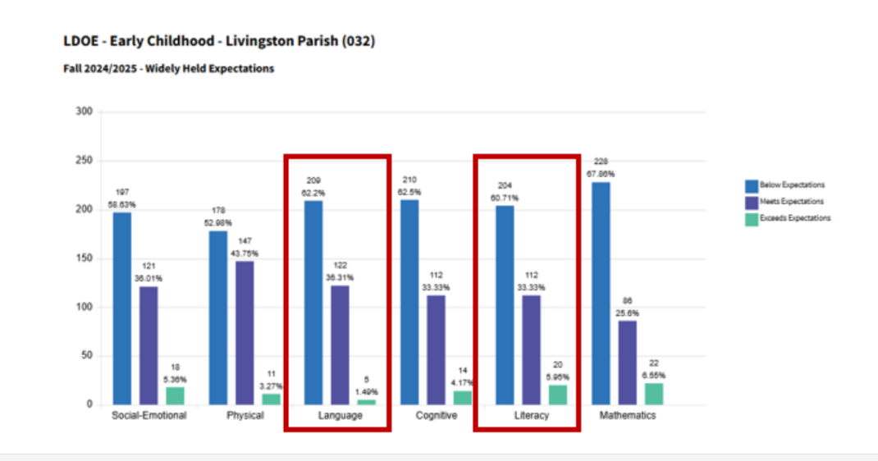

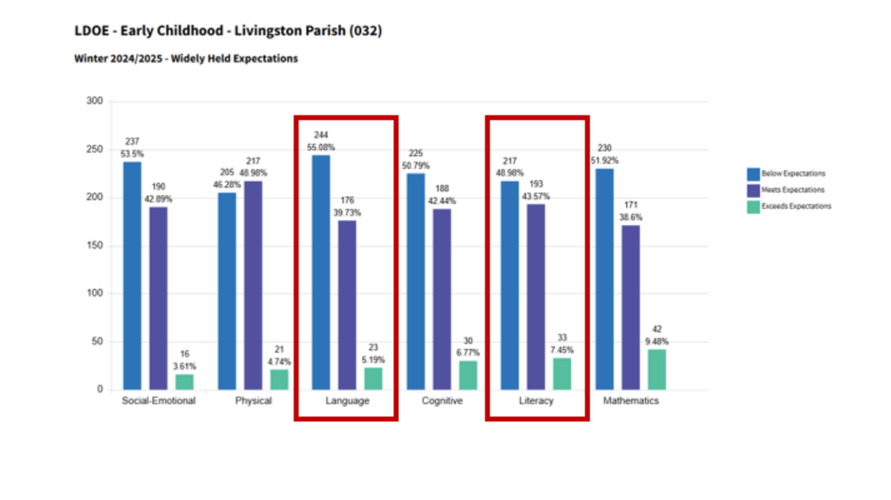

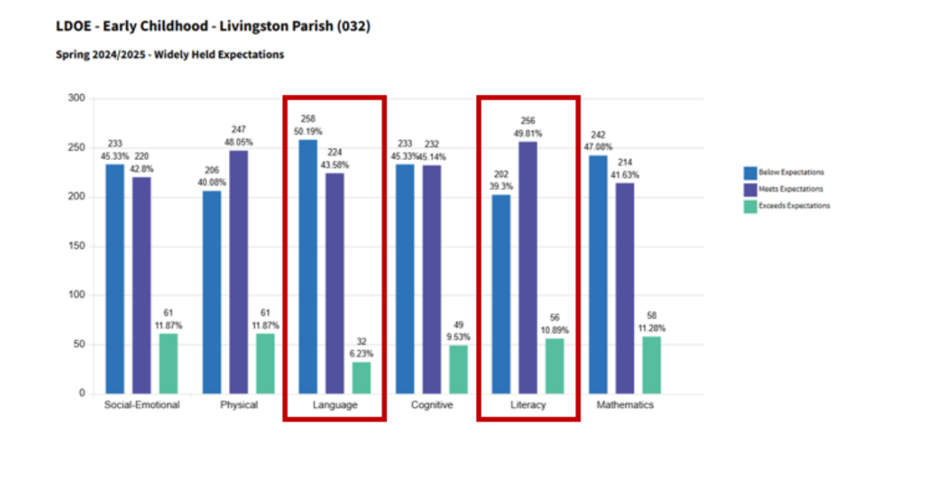

Meeting Schedules
Date & Type of Meeting (Plan Review, Data Analysis, etc.) | Frequency of Meetings (Weekly, Monthly, etc.) | Topic(s)
Beginning of the Year DIBELS Benchmark, Diagnostic results and data from Phonological Awareness/Phonics Screener | August | - Analysis of DIBELS Data, iReady Reading Diagnostic EOY LEAP Data, Phonics Screener, Phonological awareness screener  - Home Connect Reports  - Create IASP to develop intervention lessons for groups of students performing below benchmark  - Create extension lessons for at or above grade level students.
Data Review Meeting | Two times Yearly | - Tier II, Tier III, and Subgroup Students
DIBELS Progress Monitoring | Two times Yearly | - Analysis of DIBELS Data to determine if students are on track to meet grade level goals.  - Adjustments to interventions and/or groups as needed.
Phonological Awareness or Phonics Screener | Every Four-Six Weeks as needed | - Administer Phonological awareness screener or Phonics Screeners every four to six weeks to assess if interventions are working.  - Adjustments to interventions and/or groups as needed
Middle of the Year DIBELS Benchmark, Diagnostic results and data from Phonological Awareness/Phonics Screener | January | - Analysis of DIBELS Benchmark Data, iReady Diagnostic, Phonological Awareness Screener , Phonics Screener  - Home Connect Report  - Adjustments to interventions and/or groups as needed
End of the Year DIBELS Benchmark, Diagnostic results and data from Phonological Awareness/Phonics Screener | April-May | - Analysis of DIBELS Data, iReady Diagnostic, Phonological Awareness Screener Phonics Screener  - Home Connect Report

Section 2: District Literacy Team members will provide guidance for the development and implementation of Instruction, Interventions, and Extensions
Action Plan
Month | Literacy Goals | Explicit Instruction with Interventions and Extensions Ongoing | Professional Growth | Family Literacy Engagement
Summer | Work with schools to establish literacy teams that consist of:  - Principal  - Assistant Principal  - Instructional Coach  - Teachers  - Special Education Teacher  - RTI Academic Interventionist  - ELL Representative (if necessary) | Grades K-2:  - Incorporate 165 minutes (whole group and small group) of Tier I literacy instruction.  - In addition, students will receive 30 minutes of intervention/extension provided by teachers/interventionists with teachers playing an integral role.  Grades 3-5:  - Incorporate 120 minutes (whole group and small group) of Tier 1 literacy instruction.  - In addition, students will receive 30 minutes of intervention/extension provided by teachers/interventionists with teachers playing an integral role.  Review the Tier I curriculum calendar and grade level standards.  Incorporate 45 minutes per week iReady reading personalized instruction with 2 lessons a week successfully passed at a mark of 67%.  Implement Tier 1 Core Curriculum that supports implementing explicit language and literacy instruction including foundational skills, high-quality interactions, and support as evidenced by curriculum embedded assessments.  - Creative Curriculum for Early Childhood  - CKLA Skill Strand K-2 Grade  - Magnetic Reading Foundation K-2 Grade  - Wit & Wisdom Grades K-5  - My Perspectives Grades 6 -8  - HMH Grades 9 – 12  Teachers also provide grade level core differentiated instruction.  Administer the literacy screener and diagnostics to all students to identify needs including subgroups (EL, 504/Dyslexia, Sped)  - A DIBELS 8 School Team/Teacher will administer the benchmark assessment in the fall, winter, spring of the school year.  - IReady Reading Diagnostic assessments will be given to all students throughout the school year. Students identified well below, and below level on the DIBELS assessment will be given a Phonological Awareness Screener, or Phonics Screener or both.  - Teachers will progress monitor students who are well below or below grade level receiving interventions based on DIBLES 8 data.  - Teachers or interventionists (with teachers planning interventions) will provide interventions/extensions to students that target the deficit areas in phonological awareness, phonics, vocabulary, fluency, and comprehension or extend learning in reading.  Interventions will be based on these deficit areas below:  - Phonological Awareness interventions: include using materials/strategies in the LP intervention guide, 95%, Differentiated Instruction, and West Virginia. Micheal Heggerty lessons focusing on 1 of the 9 areas of concern (phoneme blending and segmenting, addition, substitution, and deletion of sounds, blending sounds, language awareness, isolating beginning, middle and final sounds, and rhyming.  - Phonics interventions: include using materials/ strategies focusing on word building using the intervention materials for phonics progression based on the student deficit. (Ex. Students use chaining lessons to build words using letters tiles, alphabet arcs, dry erase boards, and digital letter manipulation. Students practice deficit phonics skills using a variety of reading materials. (ex. Decodable text, sight words, and assisted reading with teacher/interventionist)  - Vocabulary interventions: include using Tier 1 curriculum, Wit & Wisdom, by exposing students to vocabulary with embedded read aloud activities. This helps expose students to a variety of vocabulary, language structures, and story elements. Morphology and vocabulary lessons within the Deep Dive sections of Wit & Wisdom also provide next steps for students who struggle with lessons. These next steps used as an intervention can be critical for student understanding. One example uses The Frayer Model activity to help students deepen understanding of vocabulary.  - Fluency interventions: include practicing letter sounds or letter combinations, sight words/ high frequency words with automaticity to strengthen word recognition. Students will then use various reading materials to strengthen automatic reading with guidance and support from the teacher/interventionist.  - Comprehension interventions: are based on student deficits correlating directly with phonics deficiencies. Using data from a phonic screener to target the deficit sounds and automaticity of reading, the teacher/ interventionist will use decodable Phonological awareness screener, sight words and assisted reading to strengthen reading comprehension.  Extensions:  - Teacher/Interventionist will provide extension lessons to students who are on or above grade level. These lessons can be based on grouping from iReady Reading Diagnostic and focus on grade level or above grade level standards. | Meet with literacy team to develop a plan to model, practice, and provide feedback on effective literacy practices and instruction.  Share Literacy with School leaders that are available in the LDOE Literacy Library. | Evaluate Phonological awareness screener t impact of literacy-focused family engagement opportunities and plan for improvement for the upcoming year.  Develop partnerships with community organizations to promote reading.  Include plans for family literacy engagement in the school literacy plan.  Plan for family literacy monthly activities including practical guidance to encourage regular reading in the home.
August | Enroll all new K-3 teachers and school leaders in ACT 108 Literacy Foundations Training (if not already certified)  Administer literacy screener and diagnostics.  Conduct School ILT meeting.  Communicate School Literacy Plan.  - Open House  - Literacy campaign/social media post | The Science of Reading Training and how to integrate best practices and evidence-based strategies into classrooms, including instruction for diverse learners.  Science of Reading:  Teachers attend DIBELS 8 training if not already certified.  Teachers attend iReady Reading training if not already attended.  Set well-defined and measurable goals for Tier I curriculum implementation (including timelines and strategies for monitoring the implementation and ensuring continuous improvement and evaluation).  Teachers will follow the pacing calendars for Tier 1 ELA curriculum.  Establish well-organized classrooms that exhibit clear routines and access to high-quality literacy materials that support diverse learning activities.  Provide feedback and support for effective curriculum planning and implementation.  Share literacy resources from Literacy Library with teachers. | District and School leaders provide teachers with professional development in Literacy Instructional Practices.  Test coordinators, teachers and test administrators complete 2-hour DIBELS mClass training | Develop a plan to disseminate information to families including opportunities for them to be involved in promoting their child’s language and literacy development.  Share the literacy Resources by using Kinvo calls (School Messenger), paper copies, digital platforms for Families activities in the LDOE Literacy Library.
September | Provide guidance on developing Student Learning Targets.  Conduct District ILT meeting. | Analyze beginning of the year literacy screener and diagnostic data at the district, school and teacher level. Use data and flexible scheduling to create targeted intervention and extension groups.  Conduct additional screeners for students at risk for dyslexia as needed.  Plan for how teachers/ interventionists will use progress monitoring data to adjust intervention/extension groups.  Provide ongoing data-driven planning and professional collaboration with faculty and staff providing interventions for well below or below level students and subgroups (SPED, 504/Dyslexia, EL).  Provide ongoing opportunities for data-driven planning and professional collaboration with faculty and staff providing guidance for extension lessons and standards alignment.  Meet with grade levels to analyze end of unit assessments and end of module assessments for Tier 1 ELA curriculums to ensure all students have access to a quality Tier 1 curriculum. | Support teachers with information on evidence-based literacy strategies and where they exist in their Tier 1 curriculum.  MRF/CKLA: Foundational skills Phonological Awareness and phonics lessons are essential evidence-based literacy strategies.  Wit and Wisdom: Read aloud texts support students understanding of informational and narrative stories. This knowledge building curriculum allows students to deepen vocabulary, fluency, comprehension, and writing.  Support teachers and interventionist with analyzing data for EL students grouping, and interventions using DIBELS 8 data, iReady Reading Diagnostic, Phonological Awareness Screener and Phonics Screener and ELPT proficiency levels.  (Students who score at beginning levels of ELPT will have PA and phonics skill instruction during interventions). | Highlight Literacy Focus of the Month, For Example: Hispanic Heritage Month  Share the literacy Resources by using Kinvo calls (School Messenger), paper copies, digital platforms for Families activities in the LDOE Literacy Library.  Provide families with Home Connect Report/ Home Connects Letter that includes intervention support and activities for families to complete at home.
October | Conduct District ILTTeam meeting. | Use progress monitoring data to adjust intervention/extension groups.  Use updated Phonological Awareness Screener or Phonics Screener to adjust intervention/ extension groups.  Provide ongoing data-driven planning and professional collaboration with faculty and staff providing interventions for well below or below level students and subgroups (SPED, 504/Dyslexia, EL).  Provide ongoing opportunities for data-driven planning and professional collaboration with faculty and staff providing guidance for extension lessons and standards alignment.  Meet with grade levels to analyze end of unit assessments and end of module assessments for Tier 1 ELA curriculums to ensure all students have access to a quality Tier 1 curriculum.  . | Continue providing coaching support and feedback to teachers based on principal request, progress monitoring, updated screeners and LER observations.  Resources in the Louisiana Literacy Library are available to support professional learning.  Support teachers and interventionist with analyzing data for EL students grouping, and interventions using DIBELS 8 data, iReady Reading Diagnostic, Phonological Awareness Screener and Phonics Screener and ELPT proficiency levels.  (Students who score at beginning levels of ELPT will have PA and phonics skill instruction during interventions). | Highlight Literacy Focus of the Month, For example: Learning Disabilities and Dyslexia Awareness Month  Share Grab and Go Activities with families to support at home learning.  Share the literacy Resources by using Kinvo calls (School Messenger), paper copies, digital platforms for Families activities in the LDOE Literacy Library.  Literacy Night: Provide parents with an opportunity to learn how to help their children with literacy. Provide take home engaging activities for all students to promote increased literacy involvement.  Have parents complete a detailed survey to rate the effectiveness of literacy night.
November | Conduct District ILT Team meeting | Use progress monitoring data to adjust intervention/extension groups.  Provide ongoing data-driven planning and professional collaboration with faculty and staff providing interventions for well below or below level students and subgroups (SPED, 504/Dyslexia, EL).  Provide ongoing opportunities for data-driven planning and professional collaboration with faculty and staff providing guidance for extension lessons and standards alignment.  Meet with grade levels to analyze end of unit assessments and end of module assessments for Tier 1 ELA curriculums to ensure all students have access to a quality Tier 1 curriculum. | Continue providing coaching support and feedback to teachers based on principal request, progress monitoring, updated screeners and LER observations.  Support teachers and interventionist with analyzing data for EL students grouping, and interventions using DIBELS 8 data, iReady Reading Diagnostic, Phonological Awareness Screener and Phonics Screener and ELPT proficiency levels.  (Students who score at beginning levels of ELPT will have PA and phonics skill instruction during interventions). | Highlight Literacy Focus of the Month, For example:  American Indian, Alaska Native, and Native Hawaiian Heritage Month  Share the literacy Resources by using Kinvo calls (School Messenger), paper copies, digital platforms for Families activities in the LDOE Literacy Library.
December | Progress monitor Student Learning Targets.  Conduct District ILT Team meeting | Administer mid-year literacy screener and iReady Reading Diagnostic.  Analyze DIBELS Data, iReady Reading Diagnostic, Phonological Awareness Screener / Phonics Screener  Intervention plans will be adjusted based off new data acquired from Literacy screener, Phonological Awareness Screener / Phonics Screener  Provide Home Connect Report, including chart tracking progress towards goal. | Continue providing coaching support and feedback to teachers based on principal request, progress monitoring, updated screeners and LER observations. | Highlight Literacy Focus of the Month, For example: Holiday Traditions and Customs  Share the literacy Resources by using Kinvo calls (School Messenger), paper copies, digital platforms for Families activities in the LDOE Literacy Library.  Provide families with Home Connect Report that includes a chart tracking progress toward goals, intervention support and activities for families to complete at home.
January | Conduct District ILT Team meeting.  Based on mid-year screening data, assess and chart progress towards initial literacy goals.  Communicate to families the progress students are making toward their individual literacy goals. | Support schools in:  Analyzing mid-year literacy screener and diagnostic data at the school, and teacher level.  Adjust intervention and extension groups based on student needs.  Provide Home Connect Report, including chart, and tracking progress toward student goals.  Provide ongoing data-driven planning and professional collaboration with faculty and staff providing interventions for well below or below level students and subgroups (SPED, 504/Dyslexia, EL).  Provide ongoing opportunities for data-driven planning and professional collaboration with faculty and staff providing guidance for extension lessons and standards alignment.  Meet with grade levels to analyze end of unit assessments and end of module assessments for Tier 1 ELA curriculum to ensure all students have access to a quality Tier 1 curriculum. | Continue providing coaching support and feedback to teachers based on principal request, progress monitoring, updated screeners and Kickup observations.  Based on mid-year screening data and classroom observation, adjust your professional learning calendars.  Support teachers and interventionist with analyzing data for EL students grouping, and interventions using DIBELS 8 data, iReady Reading Diagnostic, Phonological Awareness Screener and Phonics Screener and ELPT proficiency levels.  (Students who score at beginning levels of ELPT will have PA and phonics skill instruction during interventions). | Highlight Literacy Focus of the Month, For Example: National Creativity Month- Celebrate creativity of your students.  Continue to develop partnerships with community organizations to promote reading.  Share the literacy Resources by using Kinvo calls (School Messenger), paper copies, digital platforms for Families activities in the LDOE Literacy Library.  Provide families with Home Connect Report that includes a chart tracking progress toward goals, intervention support and activities for families to complete at home.
February | Conduct District ILT Team meeting | Use progress monitoring data to adjust intervention/extension groups.  Use updated Phonological Awareness Screener or Phonics Screener to adjust intervention/ extension groups  Provide ongoing data-driven planning and professional collaboration with faculty and staff providing interventions for well below or below level students and subgroups (SPED, 504/Dyslexia, EL).  Provide ongoing opportunities for data-driven planning and professional collaboration with faculty and staff providing guidance for extension lessons and standards alignment.  Meet with grade levels to analyze end of unit assessments and end of module assessments for Tier 1 ELA curriculums to ensure all students have access to a quality Tier 1 curriculums. | Continue providing coaching support and feedback to teachers based on principal request, progress monitoring, updated screeners and LER observations.  Support teachers and interventionist with analyzing data for EL students grouping, and interventions using DIBELS 8 data, iReady Reading Diagnostic, Phonological Awareness Screener, and Phonics Screener and ELPT proficiency levels.  (Students who score at beginning levels of ELPT will have PA and phonics skill instruction during interventions). | Highlight Literacy Focus of the Month, For Example: Black History Month  Share the literacy Resources by using Kinvo calls (School Messenger), paper copies, digital platforms for Families activities in the LDOE Literacy Library.
March | Conduct District ILT Team meeting | Use progress monitoring data to adjust intervention/extension groups.  Provide ongoing data-driven planning and professional collaboration with faculty and staff providing interventions for well below or below level students and subgroups (SPED, 504/Dyslexia, EL).  Provide ongoing opportunities for data-driven planning and professional collaboration with faculty and staff providing guidance for extension lessons and standards alignment.  Meet with grade levels to analyze end of unit assessments and end of module assessments for Tier 1 ELA curriculums to ensure all students have access to a quality Tier 1 curriculums. | Continue providing coaching support and feedback to teachers based on principal request, progress monitoring, updated screeners and LER observations.  Support teachers and interventionist with analyzing data for EL students grouping, and interventions using DIBELS 8 data, iReady Reading Diagnostic, Phonological Awareness Screener and Phonics Screener and ELPT proficiency levels.  (Students who score at beginning levels of ELPT will have PA and phonics skill instruction during interventions). | Highlight Literacy Focus of the Month, For Example: NEA's Read Across America  Share the literacy Resources by using Kinvo calls (School Messenger), paper copies, digital platforms for Families activities in the LDOE Literacy Library.  Everything Reading: Provide workshops to parents explaining how to help students with reading deficits. Have parents complete a detailed survey to rate the effectiveness of workshop.
April | Conduct District ILT Team meeting | Use progress monitoring data to adjust intervention/extension groups.  Provide school leaders with guidance to build master schedules for following school year to include:  - Weekly common planning  - Literacy block with embedded intervention/ small group time  Screen ALL kindergarten students for Dyslexia and follow up with further assessments for students who indicate that they are at risk. | Continue providing coaching support and feedback to teachers based on principal request, progress monitoring, updated  screeners and LER observations.  . | Highlight Literacy Focus of the Month, For Example: National Poetry Month, Drop Everything and Read Day (April 12)  Share the literacy Resources by using Kinvo calls (School Messenger), paper copies, digital platforms for Families activities in the LDOE Literacy Library.
May | Conduct District ILT Team meeting  Review early literacy screener end-of-year data to set goals for next year.  3rd grade students who score well below will have an addition third screener after two weeks of intensive literacy intervention during the summer months | Analyze end-year literacy screener and diagnostic data at the school, and teacher level.  Use data from monitoring of curriculum implementation to determine if:  additional professional development/support is needed.  Provide Home Connect Report, including chart including tracking progress toward student goals.  2nd and 3rd grade students who are well below grade level will be offered Summer Literacy Boost. | Attend Literacy sessions at the Louisiana Teacher Leader Summit  Report the number of K-3 teachers and leaders who have completed ACT 108 Literacy Foundations Training  Professional development on intentional literacy interventions at the LPPS Summer Reading Institute | Highlight Literacy Focus of the Month, For Example: Asian Pacific American Heritage  Share the literacy Resources by using Kinvo calls (School Messenger), paper copies, digital platforms for Families activities in the LDOE Literacy Library.  Provide families with Home Connect Report that includes a chart tracking progress toward goals, intervention support and activities for families to complete at home.

Section 3: Ongoing Professional Growth
Potential PD Planning

Month/Date  (When can PD be scheduled throughout the school year?) | Topics  (What topics are most needed and should be covered and/or prioritized?) | Attendees  (Who would benefit most from this PD? Consider also who can deliver to other teachers/faculty.)
August – May | Ongoing professional development and support aimed at building knowledge and capacity around the Science of Reading and how to integrate best practices and evidence-based strategies into classrooms, including instruction for diverse learners.  District Support Team members will observe with a LER instrument to ensure Tier I curriculums, best practices and evidence-based strategies are implemented. Coaching based on literacy data and observations will be provided as necessary to ensure all students including subgroups are provided the best education possible.  School ILT Teams will discuss monthly students in subgroup categories and meet with teachers to review students’ data and progress.  Science of Reading:  • LETRS for Early Childhood  • Canopy (K-3) | School Leaders  Teachers
August - May | Attend core curriculum training and support for collaborative planning amongst grade level teachers.  • Creative Curriculum for Early Childhood  Magnetic Reading Foundation Grade K-2  • CKLA Skill Strand Grades K-2  • Wit & Wisdom Grades K-5  • Writing K - 12  • My Perspectives 6 - 8  • HMH 9 - 12 | School Leaders  Teachers
August-May | Ongoing professional development and support determined by analysis of LER data.  New Teachers will receive beginning training on each of the curriculums used in the district.  Teacher Collaboration Meetings will be established. | School Leaders  Teachers
May | Supervisors of Elementary Curriculum will assist and approve master schedules that include weekly common planning and literacy block with embedded interventions | School Leaders

Section 4: Family Engagement Around Literacy
Month/Date | Activity | Accessibility Opportunities | Community Partners
September, January, & May | Distribute the Home Connect Report to parents/guardians within fifteen days of identifying that a student in kindergarten through third grade is below grade level. Written notice given in the BOY, MOY, and EOY shall include:  • importance of reading on grade level by the end of third grade  • at home literacy activities  • Specific interventions and support provided at school | Home Connect reports will be sent home in the fall, winter, and spring, including chart showing progress toward student goals.  Parent/Teacher Conferences | LDOE
August | Open House/ Meet & Greet | ZOOM, Informational brochures & flyers | Smoothie King, LPSO
August - May | Provide families access to various literacy resources and information for at-home use through the district Family Resource Center. | Workshops, Digital Resources | Family Resource Center
August - May | Partner with local library branches to offer each student a digital library card. | Online library access | Local library branches

Section 5: Alignment to other Initiatives
Initiative Alignment

Other Programs/Initiatives | Connecting to Literacy | Plan to Monitor/Evidence of Success
Science of Reading training | LDOE provided Science of Reading Training | Teachers will complete the Reading training throughout the school year and become knowledgeable of best practice and understand how to identify children's reading needs.  Science of Reading/ LETRS Certificates will be kept on file.
Alignment to district Tier 1 literacy curriculum | CKLA / Wit & Wisdom, Magnetic Reading  My Perspectives  HMH | Unit/ Module Assessment Data, LER Observation Data
Interventions/ Extensions | School based face to face interventions & i-ready Reading Computer Instruction | Reading Intervention logs/ iReady Reading Reports  DIBELS 8 Data: BOY, MOY, EOY
Literacy Night | Parents and students interact with staff and teachers with literacy strategies | Sign- in sheets, parent surveys
Family Monthly Literacy Communication | Monthly Literacy Focus | Newsletter, home activities, Home Connect report, highlight literacy strategies on school websites.  Grab and Go Activities with families to support at home learning.
School Improvement Plan | Analysis of Literacy data and the inclusion of the literacy plan | Schools will include their literacy plan in the school improvement plan. Schools will focus on deficits in reading and plan for improvements.
Livingston Parish Intervention Library | Provide families access to a variety of literacy resources | Attendance at workshops, Checkout of materials at Resource Center

Section 6: Communicating the Plan
Communication Plan

Stakeholder Group | Plan for Communicating | Timeline
Principal, Asst Principal, Teachers Students, Parents, Community | The school literacy plan will be posted on the school website. | Post on Website by August 1, 2025
School’s Literacy Team | The literacy team has published meeting dates throughout the year. | Monthly
District Curriculum Department  School Literacy Team | District Personnel will support schools with literacy, interventions, and curriculum. | August - May
Family Members | The school literacy plan will be posted on the school website. | Post on Website by August 1sr, 2025
Family Members | Parents will receive Home Connect Reports to show student progress, interventions, and what Home Connects can do to support their child at home. | BOY, MOY, EOY

