



Denham Springs Elementary
2022-2023

Denham Springs Elementary School
306 N. Range Ave.
Denham Springs, LA 70726
http://www.denhamspringselem.org

Office: 225-665-5855
Fax: 225-664-8672

Grades: Pre-K - 5th Grade
School Mascot: Yellow Jacket
School Colors: Purple and Gold
School Motto: Learners Today; Leaders Tomorrow

Principal: Bridget Castille
Principal Designee: Alysha Leonard
Instructional Coach: Kayla Jarrell

Livingston Parish Public Schools
225-686-7044
www.lpsb.org

TABLE OF CONTENTS

School Calendar ………………………………………………………………………………………. P. 1
Arrival ………………………………………………………………………………….……………….. P. 2
Tardy Check-In/Early Check-Out …………………………………………………………………. P. 2
Dismissal and Transportation …………………………………………………….……………….. P. 3
Custody Information ………………………………….…………………………….……………….. P. 4
Emergency Contact Information …………………………….…………………………………….. P. 4
Attendance …………………………………………………………………………………………….. P. 4
Medications …………………………………………………………………………..………………… P. 5
Health Rules …………………………………………………………….……………………………… P. 6
Students Calling Home …………………………………………………………….………………… P. 8
Visitors …………………………………………..……………………………………………………… P. 8
Lost and Found ………………………………………………………………………………………... P. 8
Miscellaneous Information for Parents ……………………………………………………………. P. 8
Published Photographs and Work ………………………………….…………….……………….. P. 8
Parent/Teacher Conferences ……………………………………………………………………….. P. 9
Grading Scale …………………………………………………………………………………………… P. 9
Code of Honor ………………………………………………………………………..………………… P. 9
Parties …………………………………………………………………………………..……………….. P. 10
Selling or Buying at School ………………………………………………………………………….. P. 10
Fees ……………………………………………………………………………………..……………….. P. 10
Concessions …………………………………………………………………………..……………….. P. 11
Book Club Orders …………………………………………………………………….……………….. P. 11
Field Trips ……………………………………………………………………………..……………….. P. 11
Fund Raisers …………………………………………………………………………..……………….. P. 11
Cafeteria ………………………………………………………………………………..……………….. P. 12
Breakfast and Lunch Prices ………………………………………………………………………….. P. 12
Dress Code …………………………………………………………………………….……………….. P. 12
General Procedures and Rules for Students …………………………………….……………….. P. 15
Harassment Policy………………………………………………………………………………………. P. 16
Bus Policies …………………………………………………………………………….……………….. P. 16
Discipline ………………………………………………………………………………………………… P. 16
Student Computer Access and Use ……………………………………………….……………….. P. 17
Electronic Communications…………………………………………………………………………… P. 18
Child Search………………………………………………………………………………………………. P. 18
DSE Sports………………………………………………………………………………………………… p. 18
Emergency Planning Guide for Parents ……….……………………………………………..……. P. 19
Denham Springs Elementary Title I Parental Involvement Policy………………………………. P. 21
Student Accident Insurance Coverage………………………………………………………………. p. 24

Livingston Parish Public Schools Calendar 2021-2022
Planning/Preparation (TEACHERS and PRINCIPALS) Fri/Mon/Tues/ August 6, 9, &10, 2021 (Full Days)
First Semester Begins (STUDENTS – A-K) Wednesday, August 11, 2021 (Full Day)
First Semester Begins (STUDENTS – L-Z) Thursday, August 12, 2021 (Full Day)
LPPS Professional Development* Wednesday, September 22, 2021 (Full Day)
First Semester Ends (STUDENTS) Tuesday, December 21, 2021
Planning/Preparation (TEACHERS and PRINCIPALS)* Thurs/Fri, January 6-7, 2022 (Full Days)
Second Semester Begins (STUDENTS) Monday, January 10, 2022
LPPS Professional Development* Wednesday, March 23, 2022 (Full Day)
Second Semester Ends Wednesday, May 25, 2022

SCHOOL HOLIDAYS (STUDENTS)
Labor Day Monday, September 6, 2021 (1 Day)
LPPS Professional Development* Wednesday, September 22, 2021 (1 Day)
Livingston Parish Fair Friday, October 8, 2021 (1 Day)
Convention and Thanksgiving Monday - Friday, November 22-26, 2021 (5 Days)
Christmas and New Year’s Wednesday, December 22, 2021 - Friday, January 7, 2022 (13 Days)
Martin Luther King Day Monday, January 17, 2022 (1 Day)
Mardi Gras Friday - Tuesday, February 25 – March 1, 2022 (3 Days)
LPPS Professional Development* Wednesday, March 23, 2022 (1 Day)
Good Friday/Easter Monday – Friday, April 11- 15, 2022 (5 Days)
*School staff will observe all holidays with the exception of those designated as for planning and in-services.

PROGRESS REPORTS TO BE ISSUED
ELEMENTARY & JUNIOR HIGH | SECONDARY
Monday September 13, 2021  Friday November 12, 2021  Thursday February 10, 2022  Friday April 22, 2022 | Monday September 13, 2021  Monday October 11, 2021  Friday November 12, 2021  Thursday February 10, 2022  Wednesday March 16, 2022  Friday April 22, 2022

GRADING PERIOD ENDS/ELEM. & JUNIOR HIGH | GRADING PERIOD ENDS/SECONDARY

Wednesday October 13, 2021 - 44 days  Tuesday December 21, 2021 - 44 days  Wednesday March 16, 2022 - 44 days  Wednesday May 25, 2022 - 45 days | Tuesday December 21, 2021 - 88 days  Wednesday May 25, 2022 - 89 days

REPORT CARDS TO BE ISSUED
ELEMENTARY AND JUNIOR HIGH | SECONDARY

Tuesday October 19, 2021  Wednesday January 19, 2022 January 9, 2012  Tuesday March 22, 2022  Wednesday June 1, 2022 | Wednesday January 19, 2022  Wednesday June 1, 2022

ARRIVAL
  - Student drop off begins at 7:05 a.m. Cars may not enter drive until 7:05.
  - School begins at 7:30 a.m. All students are to report to their assigned area upon arrival. Students may be given a breakfast if they arrive by 7:20 a.m.
  - Students arriving after 7:30 a.m. are tardy and must be accompanied by an adult to the office and signed in.
  - Carpool students must be dropped off in the unloading area. DO NOT DROP OFF STUDENTS AT ANY OTHER LOCATION. Cars will enter from College Drive from Cedar and exit onto Cedar.
  - CARS MAY NOT LINE UP FOR CARPOOL BEFORE THE GATE IS OPEN! The police department wants to ensure the streets are not blocked by waiting cars.
  - Visitors may not walk the child to his/her classroom in the morning.

TARDY CHECK-IN/EARLY CHECK-OUT
Prompt arrival at school is expected of all students. Late arrival disrupts class and causes loss of instructional time. If a student arrives at school after 7:30 a.m., he/she is considered tardy. The child’s parent must report to the office to check in. Your child will receive a note to give to the teacher. A valid excuse for a late check-in must be presented to the school to avoid receiving an unexcused tardy.
The following disciplinary action will apply for excessive tardiness:

- On the fifth unexcused tardy, the parent will receive a letter from the principal and ½ day unexcused absence will be entered for the student for that date.
- On the tenth unexcused tardy, students will receive a ½ day unexcused absence, and the family will be referred to FINS through the court system.

A student should be checked out for illness, doctor appointments, and verifiable emergencies only. The lack of a valid excuse may result in a grade of “0” being assigned for missed work.

Students may not be checked out after 2:00 p.m. After this time, parents must pick up their child in the carpool line (a carpool tag will be needed). Early check out will have the same guidelines as a tardy. Students have instruction until the end of the day.

2
In accordance with state and local policy, students who have 10 or more tardies or check-outs will be reported to the Parish Supervisor of Child Welfare and Attendance as well as the 21st Judicial Court System Families in Need of Service (FINS/TASC Program).

DISMISSAL AND TRANSPORTATION

- Dismissal time is 2:30 p.m. Students will be escorted to dismissal area.
- Carpool line will enter from College Drive from Cedar. Please do not turn on College from Range.
- No K-5 carpool vehicle may enter before 2:15 p.m. All carpool vehicles must have a carpool tag placed on the passenger side dashboard and visible to the duty teachers. No hand-held devices (phones) may be used in carpool line!
- If you do not have a carpool tag, you will be sent to the office to get one. You will need to show your picture ID in order to obtain a carpool tag.
- All after-school arrangements MUST be made before students come to school.
- Any changes to a student’s normal mode of transportation must be made in writing.
FOR YOUR CHILD’S SAFETY, NO CHANGES WILL BE MADE BY TELEPHONE.
- Students participating in sports or club events may stay after school dismisses. This does not include siblings.
- Students may only ride on their assigned bus.
- No student will be checked out after 2:00 p.m.
- Students will not be released to any person(s) not on their Check-Out Card or their Student Information Form. Please keep this information current.
- Students who check out early for appointments must present the teacher with a doctor’s excuse upon their return to school.
- PHOTO ID WILL BE REQUIRED FOR ALL CHECK-OUTS.

EARLY EMERGENCY DISMISSAL

Emergency dismissal will take place only under extreme circumstances such as severe weather, a public crisis, etc. Your child must be aware of your alternate plan (where he/she should go) in case of an early emergency dismissal. All students will be transported home in their usual way. Buses will drop off students at their regular bus stops. If there is a possibility that the parent/guardian will not be home, arrangements should be made as to where the student will go. Parents will be contacted through the media and School Messenger if such an emergency occurs. Please make sure your contact information remains current including your email.

- Every child at Denham Springs Elementary should be able to recite his/her street address and phone number the first day of school.

3

CUSTODY INFORMATION

If there is a custody issue involving your child, current custody papers must be on file in the office. This must be updated each year.

EMERGENCY CONTACT INFORMATION
Please keep your child’s information updated. It is important that we have AT LEAST TWO WORKING emergency contact numbers in the event your child becomes ill or injured at school.

ATTENDANCE

In order to be promoted to the next grade, students are allowed no more than 10 unexcused absences for the year.

Students will be marked a ½ day absent if they miss 25 to 50% of the day and will be marked absent for a full day if they miss 51 to 100% of the day.

In accordance with state law, the following absences will be considered excused with appropriate documentation within five days of the absence:

- Personal illness documented by a physician’s note. (It is within the school’s rights to call the physician and verify an excuse.)
- Serious illness or death in the immediate family (not to exceed one week).
- Emergency medical or dental attention.
- Contagious disease in the family.
- Other absences excused by the principal: Contact the school regarding policy related to extended absence due to illness, injury, or a death in the family.

Students will get 1 day to make up work for every day out. Students who check out and return the next day are still responsible for homework assignments.

Parents should plan vacations to coincide with school holidays. Vacations during school time cause a loss of learning. These absences will be unexcused and are highly discouraged.

FINS (Families in Need of Service) will be contacted if
a student has:

- 4 or more unexcused absences during the first 9-weeks (fewer if absences were excessive in the previous year)
- 8 unexcused absences for the entire year
4.

MEDICATIONS

Students are not allowed at any time to bring prescriptions or over-the-counter medications (including cough drops) to school. Medications such as antibiotics, which are given three (3) times a day, should be given at home, before school, and after school, unless otherwise directed by a doctor.

If a child is required to take medication or an injection during school hours, and the parent or guardian cannot come to the school to administer the medication, a trained school employee may do so in compliance with the following regulations:

- A Doctor’s Order Form and Parent Permission Form must be properly completed and delivered in person by the parent or guardian to the principal or appointed designee of the school. Forms can be obtained from the school office.
- All medications to be administered by school personnel must be prescribed and directions given by a physician for administering the medicine.
- No topical medication shall be applied to the student’s skin in any form.
- No prescribed or over-the-counter medications such as eye drops, ear drops, or other ointments, sprays, or lotions are permitted.
- The appropriate school employee administering oral medication will require that the student ingest the medication in his/her presence.
- An adult must bring medication to school. Any changes in medication or dose must be accompanied by a new consent and doctor’s order form.
- The student’s parent must pick up all medication before the end of May or the remaining medication will be properly discarded.
- The principal, with the superintendent’s approval, may reject any request for administration of medicine. A written reason will be given by the principal to the person making the request.

5
LIVINGSTON PARISH PUBLIC SCHOOLS
HEALTH RULES

The following guidelines are offered to help you determine when your child should not attend school. Please consider carefully a child’s statement of feeling ill.

- Diarrhea/vomiting: Students who are vomiting or having diarrhea (2 or more watery stools) will be sent home from school. They will not be allowed to return until they are symptom free for 24 hours from the onset of symptoms.

- Fever: Students who have a fever of 100.0 F or higher will be sent home. Students will be readmitted after they have been fever free for 24 hours without the use of fever reducing medications. (ex: Tylenol, Motrin, or Advil).

- Cold/flu: Students with severe colds, sore throats, cough or “flu like” symptoms will not be allowed to stay at school. They should stay home for rest and proper attention to their symptoms.

- Pink Eye: Symptoms of pink eye such as eye drainage, crusty eyelids, redness on the white part of the eyes, swelling, and itching may indicate pink eye, which is a contagious disease. Children with these symptoms will be sent home and should be seen by a doctor for a diagnosis. A doctor’s excuse will be required to return to school. If diagnosed with pink eye, the student must be on treatment for at least 24 hours before he can return to school. Some conjunctivitis may require the student remain at home until all symptoms are resolved.

- Rash/Lesions: A student with an undiagnosed rash or lesion will not be allowed to stay at school. Skin rashes or lesions will be considered possibly contagious until a student has seen his physician and has a note that it is ok to return to school.

- Medication: If your child needs to take medications for chronic conditions at school please contact your school nurse. State law requires a medication administration form be completed by the physician and parent. This includes prescription and over-the-counter medications. If a student is prescribed a new medication, they must remain at home for 12 hours after the first dose to be observed for adverse reactions.

6
- Lice: A student’s hair must be free of nits and bugs in order to remain at school. The student will be readmitted to school after the parent has treated the child and all nits and bugs are removed. After successful treatment, the parent will need to bring the student to the office to be rechecked for lice by school personnel before being allowed to stay at school. It is recommended that parents check their child on a regular basis for signs of head lice.

- Immunizations: Louisiana State Law Statute LA R.S. 17; 170 All students entering school for the first time shall present evidence of completed immunization records.
All students entering 6th grade AND 11 years old, or any student who is 11 years old (regardless of grade) shall present evidence of age appropriate vaccinations including a Tdap Booster, Meningitis vaccine, and a second varicella (chickenpox).
Students who have not received proper immunizations may not be allowed to come to school if there is an outbreak of a communicable disease at school (Chickenpox, Measles, Pertussis, etc.). By state law, these students must be excluded from the school setting. These absences will not be excused.
Parents of students that are unable to receive their immunizations due to medical, religious, or personal reasons must submit a written letter of dissent that has been notarized. If this dissent is due to a medical reason, a written statement from the doctor must be received.

- Vision/Hearing: Students’ vision and hearing are screened by the school nurse in Pre-K, Kindergarten, 1st, 3rd, 5th, and 7th grades and from parent or teacher referrals. If a problem is detected notes will be sent home to the parent referring them to their physician for a more complete evaluation.

- Scoliosis: Students are screened in 6th grade for curvature of the spine. If signs are seen, students will be sent home with a letter referring them to their physician for a more complete evaluation.

- Medical Conditions: If your child has a chronic medical condition, contact the school nurse annually. Some examples of chronic medical conditions are: Seizures/Epilepsy, diabetes, asthma, celiac disease, severe allergic reactions to insects or food that require use of an Epipen or Benadryl during the school day. A SPECIAL DIET ORDER form is required annually from a physician if your child has specific food allergies.
If you have any questions or concerns, you may call Jennifer Wilkinson, RN School Nurse Coordinator at (225)686-4368 or contact the school nurse at your child’s school.
7.

STUDENTS CALLING HOME

Students will not be allowed to call home to ask for forgotten items. Parents will be called if students are ill or for other emergencies. If your child has a medical condition that may require frequent calls, please inform the teacher and office staff.

VISITORS

All visitors must check in at the school office for a visitor’s pass. Parent conferences and visits to the classrooms must be prearranged through the classroom teacher. All visitors must wear a visitor’s tag.

LOST AND FOUND

Clothing items that are found on the school campus will be placed in the Lost and Found. Money, jewelry, and other items of value will be turned in to the office. Please write the student’s first and last name on all removable clothing. Unclaimed articles will be donated to charity twice each year.

MISCELLANEOUS INFORMATION FOR PARENTS

1. Check your child’s book sack daily for homework assignments and/or notes. You will find this information in your child’s purple folder and assignment pad.
- 2. Promptly sign and return any notes/paperwork sent home with your child.
- 3. Any school property damaged or lost will be paid for by the student.
- 4. No report card will be given to students who owe money or have lost books.
- 5. Graded assignments will be sent home on Wednesdays. Folder must be signed to indicate they were received.

PUBLISHED PHOTOGRAPHS AND WORK

There are many opportunities for Denham Springs Elementary to publish students’ pictures, interviews, and/or work in local newspapers, journals, the school web-site, and/or local news stations. Parental permission will be assumed unless specifically denied. Parents must mail or bring a refusal letter to the principal.

8
All Audio and video recordings are not allowed at DSE due to possible violations of FERPA and HIPPA, both of which regulate and protect the right to privacy for adults and minors. Any audio or video recordings at DSE require the prior approval of the Principal. Please note that this policy does not apply to general assemblies, award ceremonies, and other school sponsored events at DSE.

PARENT/TEACHER CONFERENCES

A conference to discuss your child's progress can be scheduled by sending a note or emailing the teacher. If you are unable to attend your conference, please call the office at 225-665-5855 to reschedule.

GRADING SCALE

Livingston Parish and Denham Springs Elementary Grading Scale
93% - 100% = A
85% - 92% = B
75% - 84% = C
67% - 74% = D
0% - 66% = F

Kindergarten Grading Scale
94% - 100% = E (Excellent)
80% - 93% = S (Satisfactory)
68% - 79% = N (Needs Improvement)
0% - 67% = U (Unsatisfactory)

CODE OF HONOR

All students are expected to exhibit the highest level of honesty and integrity in class assignments, school projects, homework, home projects, and testing. Students caught cheating will receive an immediate discipline referral.

9

PARTIES

Parties may be held at Christmas and Easter. No siblings are to attend. Store bought, individual treats may be brought to school for student birthdays (labeled with the child’s and teacher’s name). Please make arrangements with your child’s homeroom teacher prior to the delivery of the treats. We are unable to distribute homemade food items to the students. Please do not present gifts, balloon bouquets, or floral bouquets to students at school. These items are not allowed on the bus.

If you want to send invitations to students in your child’s class for a party given at home, either all students of the same gender or all students in the class must be invited.

SELLING OR BUYING AT SCHOOL

Students are not allowed to sell or buy anything from another student while at school. Students are not to bring items to school to be traded or given as gifts to other students.

FEES

- All money collected from students for supply fees, fundraisers, lunch, etc., must be turned in to the homeroom teacher.
- In order to ensure proper credit, please include the student’s name on the memo line and the purpose of the payment.
- Checks must have two, current phone numbers.
- The school cannot accept checks made payable to CASH.
- Separate checks must be written for each child and each different school activity.
- ALL NSF CHECKS WILL HAVE AN $10 SERVICE FEE PAYABLE TO DSE. (This fee may increase if the charges to the school by the bank are increased)
- It is strongly encouraged for all fees to be paid online. You may do this through our school website @ www.denhamspringselem.org

SUPPLY/MATERIALS FEE

- All students must pay instructional materials/supply fees.
- Please pay your child’s instructional materials/supply fee promptly (half may be paid each semester).
- A payment plan may be made on a weekly basis if needed.

10

CONCESSIONS

- The cafeteria will occasionally have extra items available for purchase at lunch such as water, pizza, ice cream, or a cereal bar.
- It is not advisable for students to have large amounts of money at school.
- Students may choose to bring a snack from home for recess. The snack should be healthy and a snack-sized portion. Drinks must be non-carbonated.
- Students should bring a bottled water from home daily.

BOOK CLUB ORDERS

Book club orders are processed through the school. Please make checks payable to Denham Springs Elementary when ordering books from book clubs such as Scholastic, etc.

FIELD TRIPS

- All school fees must be paid before a student will be permitted to attend a field trip.
- Deadlines for payment of field trips will be strictly enforced.
- Field trip fees are nonrefundable (even in cases of illness, emergency, etc.).
- The school reserves the right to prohibit a student from attending a field trip due to disciplinary issues. If a student has been suspended that semester, the student will not be allowed to attend the field trip.
- Siblings are not allowed to attend school field trips.

FUND RAISERS

By saving Community Coffee UPC labels, Coke Rewards (caps or codes), Campbell’s Soup UPC labels, and BOXTOPS For Education, we have been able to help fund our Jacket Pack (volunteers) and to purchase supplies, teaching aids, rewards for our students, and needed items for the school. Parents will be notified of additional fundraisers. These fundraisers provide wonderful educational tools for our students.

11

CAFETERIA

Information will be sent home about the charges for cafeteria meals. At the time of this publishing, we have not received the cost of meals. Please be sure to complete the free and reduced meal forms as the results of these determine our Title I allocations.
- Food brought to the cafeteria may not have a restaurant logo. This is the policy for students and staff. No carbonated beverages are allowed for students. A parent from the student’s checkout card may accompany their child for lunch as a special treat. This should occur no more than 1/month.

DRESS CODE
No student's appearance, including but not limited to his/her attire, shall be considered proper and acceptable for school if it distracts from, or in any way disrupts, the educational process. The Livingston Parish School Board is responsible for achieving a system wide dress code for appearance and dress among students that will promote the best atmosphere for teaching and learning.
DRESS AND PERSONALGROOMING
It is the responsibility of each student to use good judgment regarding appearance and attire. Cleanliness shall be a basic consideration. Any complaint concerning a student's dress and appearance shall be addressed by the particular school's administration. The principal of the particular school shall make the final decision as to what is considered proper attire and appearance. In the event that health and medical considerations for a particular student require an exception to the Dress Code, the principal of the particular school shall determine that exception and make his/her faculty and staff aware of the exception.
The following guidelines have been established regarding all student's dress and appearance:
1. Styles of dress and grooming never should be such that they represent a collective or individual protest.
2. Appropriate footwear must be worn to school (no shower shoes, flip-flops).
3. Caps, hats, unprescribed glasses are not permitted.
4. Patches, decorations, slogans, symbols, tags, marks, or advertisements are prohibited. (Examples: beer, cigarettes, drugs, obscene suggestions, sexual connotations, political, etc.)
5. Earrings are allowed for students provided they are not a safety concern or a distraction on campus.
6. Piercings, other than ears, are not permitted. Clear (concise stud only) pierce hole fillers are allowed or nose rings.
12
7. Jewelry, including earrings, worn during the school day should be a size and dimension that is not a safety concern or a distraction on campus.
8. Hair should be neat, clean, and out of the student’s eyes. Students should have natural hair color. Extreme unnatural colors are not allowed. Sculptured hair styles that include pictures, symbols, letters, numbers, or hair curlers, rollers or excessively teased will not be permitted. Principals have discretion if a hairstyle including accessories interferes with learning.
9. Neatly groomed facial hair is acceptable, including mustaches, beards and goatees.
10. Tattoos that are vulgar, obscene, political, offensive or otherwise disruptive to the school environment are not permitted and must be covered at all times.
11. Foundation garments must be worn.
12. Dress during any period where uniforms are not required, such as special event days, or for transferring students, shall be consistent with the intent and spirit of the School Uniform Dress Code.
SCHOOL UNIFORM DRESS CODE
The School Board is permitted by state law to adopt dress codes mandating the use of school uniforms. The purpose of the School Uniform Dress Code shall be to provide additional opportunities for increased school safety; to encourage students to experience a greater sense of school identity and belonging; to encourage an improvement in student behavior; and to encourage a high level of program participation.
Grades Pre-Kindergarten - 12:
Note: A color chart for skirts/shorts/slacks/skorts will be displayed to clarify the color range of Khaki.
Shirt:
• Solid color: Navy blue or white.
• Polo: (golf-boxed, hemmed) two, three or four buttons at the top front with collar (Short or Long sleeves) - Elementary students shall be encouraged to tuck in shirts. Middle/Junior High and High school students shall be required to tuck in shirts.
• Oxford/dress shirt (short or long sleeves) Elementary students shall be encouraged to tuck in shirts. Middle/Junior High and High school students shall be required to tuck in shirts.
• Designs, emblems, insignias, monograms and logos are prohibited.
• Under-shirts and t-shirts, if worn must be white, gray or black and can only be worn underneath the standard uniform.

13
• If applicable, school issued spirit shirt may be worn in place of the uniform polo on designated day set by the principal. Shall not exceed one time per week.
Pants, Skirts, Shorts, Skorts, Jumpers:
• Solid color: Khaki
• No jean, knit, jegging, stretch, cargo, capri, or cropped styles.
• Appropriate fit: not too loose, not too tight; no sagging.
• Elementary students may have elastic waist pants with or without belt loops (belts are optional, but encouraged).
• Middle/junior/high school students’ pants must have belt loops and a belt is mandatory.
• Must be worn at waistline,
• Skirts should be to top of kneecap.
• Jumpers should be to top of kneecap; not allowed for 9-12.
• Shorts/Skorts: Top of knee to four (4) inches above knee; length cannot be below the knees; length can be cuffed or not cuffed,
• The only logos allowed should be the manufacturer’s label.
• All bottoms must be hemmed.
Belts:
• PK-5: Belts are not required, but encouraged.
• Grades 6-12: Belt required with clothing designed with belt loops, any color, no inappropriate logos or slogans. Belts are to be worn correctly and buckles are not to be excessive size or offensive in design. Studs and spikes are prohibited.
Socks/ Hose/Tights:
If worn...
• Socks may not have inappropriate or offensive wording or images. Socks above the knee are prohibited.
• Tights/Leggings solid color black, gray, navy blue or white (May only be worn under skirts/dresses/jumpers). Tights must be full length reaching the ankle.
Pullovers:
• Solid Navy blue or White (¾ zip, crew, hoodies, sweaters) are allowed. A pullover cannot be worn in place of shirt nor be so large that it conceals a student’s bottom garment. Designs, emblems, insignias, monograms and logos are prohibited
• Any spirit pullover purchased from the school or a vendor with the school name or logo is acceptable.
Shoes:
• Closed-toe and closed-heel shoes are mandatory (tennis shoes, dress shoes, casual shoes or slip-on shoes or boots).
• Footwear shall not extend above the knee.
14
• Shoes shall be properly tied or strapped, if applicable.
Coats:
• Coat/jacket/sweater may be worn as long as the uniform shirt collar is revealed under the coat/jacket/sweater (trenchcoats are prohibited)
• Vests/jackets/sweaters/coats that zip/button/snap from top to bottom may be any color and with hood.
By purchasing from an approved vendor, parents will be certain the uniform will be in compliance. The acceptable color is the traditional khaki. The lighter stone color is not acceptable. The dark chocolate brown color and the dark green color are also not acceptable. If there is any doubt about a purchase regarding style and/or color, check with your school or visit an approved vendor.
Students at DSE are not allowed to have artificial fingernails. They are also not allowed to wear a smart watch or jewelry with cellular or camera access.
DSE Alternate Dress Days
Once a month, students may have the opportunity to participate in an Alternate Dress Day. On this day, students may wear regular clothes for $2. Dress code policy still applies on these days. No tank tops or spaghetti straps are allowed. Shorts may not be any shorter than 4 inches above the knee. Dresses and skirts must be no shorter than the top of the knee. No political statements may be on the garments.

GENERAL PROCEDURES AND RULES FOR STUDENTS

- Always show respect to adults and other students.
- Students are not to bring unauthorized materials to school (toys, trading cards, cell phones, iPods, Smartwatches, etc). Such items will be confiscated and released to parents.
- Toy guns, toy knives, or other toy weapons are prohibited.
- Do not bring any knives, fireworks, or dangerous weapons of any kind to school.
- No hats/caps should be worn (unless worn during a specified school event or celebration).

- Do not bring gum or candy to school.
- No tobacco, drugs, or alcohol are allowed at school.
- Students must have an office pass from the teacher to visit the school office.
- Students are not to be in a classroom without teacher supervision (before school, recess, etc.).
- Always walk in halls and on sidewalks.
- Remain on school grounds at all times.
- Do not buy, sell, loan, trade, or give away items or money at school.
- Students are expected to display desirable behavior in order to participate in extracurricular activities.
- School rules apply at all school sponsored functions in the parish.
- A student may not participate in any school activities while suspended.
15
HARASSMENT POLICY

Bullying, cyber bullying, harassment, or intimidation of any kind will not be tolerated. Students should report such behavior to a teacher or administrator. The incident will be investigated and appropriate action will be taken.

BUS POLICIES
Every student must report to his/her home immediately after dismissal from school. Each student must obey the following school bus rules:

1. Sit in assigned seat until the bus comes to a complete stop.
2. Keep head, hands, and all objects inside the bus.
3. No shouting is allowed.
4. Listen to and follow the bus driver’s directions the first time that they are given.
5. Electronic devices are not permitted on the bus.
6. If a bus driver asks for all students to remain silent, students who do not comply will receive a bus suspension.

It is very important for each student to comply with the bus rules for the safety of all children. Failure to follow the bus driver’s rules will result in a suspension from the bus. Continued non-compliance will result in the student being removed from the bus for the remainder of the school year. Students are not allowed to ride an alternative bus to a friend’s house. Drivers must have an emergency sheet on a child prior to a student riding the bus.

DISCIPLINE

We believe that classroom order is crucial to a productive learning environment. We expect all students to comply with school rules, respect others, and do their best in all things.

Students will be rewarded for following school-wide expectations. Students meeting the requirements of the DSE program will be rewarded with SWARM celebrations during the school year. To attend SWARM, students must follow expectations at least 90% of the time. The number of “checks” the student must earn, based on the number of school days, will be announced at the beginning of each SWARM period. They will also be rewarded by receiving Denham Dollars. Denham Dollars are spontaneously given to students following school-wide expectations. Students can use their Denham Dollars to purchase items at designated times. Parents are needed to assist by volunteering during SWARM celebrations.

A progressive discipline chart, or “step plan,” for each student will be maintained by the student’s teacher. (Students receiving any type of major discipline referral, including bus referrals, will automatically lose the privilege of attending any reward activities for that
16
period of time, i.e. SWARM). Recess detention, parent/teacher conferences, office referrals, and out of school suspensions are all steps in this plan. Please remember that some offenses will result in an automatic referral to the office warranting a suspension.

As a parent, you can be part of our school-wide positive behavior plan by reading and discussing these expectations with your child and make sure that he or she understands them. Encourage your child daily to make good choices, be positive and to always do their best. For repeated misbehavior, we will hold a disciplinary meeting to address concerns.

STUDENT COMPUTER AND INTERNET ACCESS AND USE

LPPS Acceptable Use Guidelines
In our continued efforts to comply with the Children's Internet Protection Act, Livingston Parish Public Schools has adopted and will enforce policies and procedures to protect our students. The policies: IFBGA Computer Access and Use and JCDAF - Bullying, Cyber bullying, Intimidation along with other district policies are available to the public at the school or district administrative office.
Acceptable use of the internet and other network resources include but not limited to:
A. No access by minors of inappropriate matter
B. No use of outside electronic mail, chat rooms, and any other forms of direct communication by students
C. No inappropriate online behavior including cyber-bullying
D. No revealing personal information.
E. No illegal activities such as:
a. Hacking, Vandalism and unauthorized access.
b. Password abuse

c. Inappropriate Language
d. Trespassing in others’ folders
e. Damaging computers or networks
f. Disabling or modifying LPPS security settings in order to bypass filtering/monitoring to gain unauthorized access to sites or files
g. Violating Copyright laws
h. Interacting with other individuals on social networking sites and in chat rooms.
i. Spreading viruses
j. Using the network for commercial, illegal or violent purposes

All students will have access to the internet while at school. Students are responsible for good behavior on school computer networks. Students are not allowed to browse the internet without direct teacher instruction and supervision. Students at DSE should not communicate over Google Classroom unless it is a teacher directed activity.

17

ELECTRONIC COMMUNICATIONS

Social interaction via electronic devices between employees and students is not allowed. This includes the use of cell phones, email, Facebook, etc.

REMIND ETIQUETTE
Teachers at Denham Springs Elementary will often use the REMIND app or the DSE app to communicate with parents. We ask that no correspondence to teachers occur after 7:00 p.m. daily. Please understand that our teachers may not be able to respond to your message until the following day. Thank you for your cooperation with this!
CHILD SEARCH
In accordance with the State of Louisiana Child Search Program, annual and ongoing activities are conducted to identify and locate children (ages 3 through 21) suspected of being exceptional and needing special education and/or related services.
If you have a child or know of a child between the ages of 3 and 5 years old who seems to have difficulty learning, help is available. Contact the Livingston Parish Public Schools Preschool Child Search Designee at (225) 686-7600 ext. 146. If your child is school-aged, contact your home-based school district regarding these concerns.
DSE SPORTS
In order to try out for school sponsored sports (4th and 5th grades only), students must not be 12 years old before September 1st and must not have any Fs the previous grading period. Students are often required to stay after school for practice. All other students (friends and siblings) are required to go home as usual immediately after school. As playing school sports is a privilege, students are expected to uphold high behavior standards. Students should not have a suspension the semester of the sport. Continued misbehavior is grounds for removal from the team. Spectators are also expected to be role models of good behavior and sportsmanship. When this is not the case, parents may be asked to leave the event and students may be removed from the team.

18
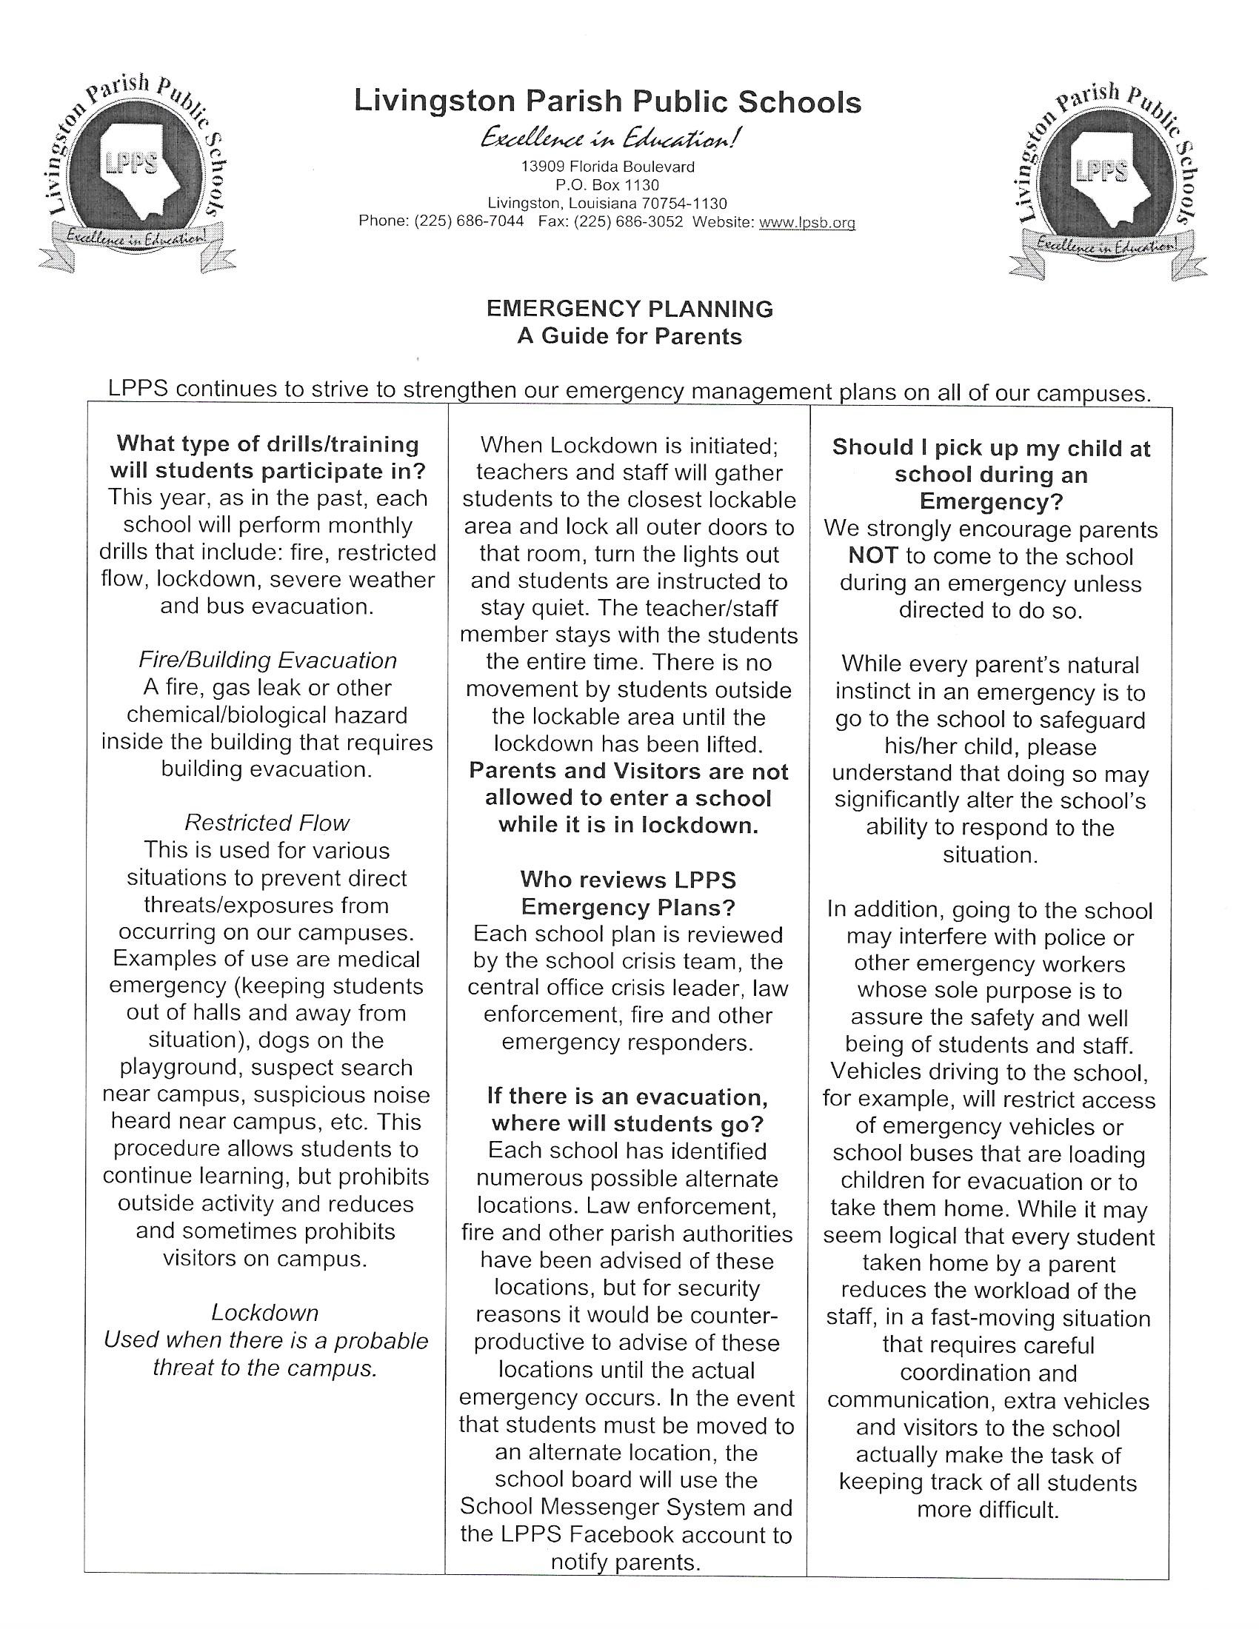

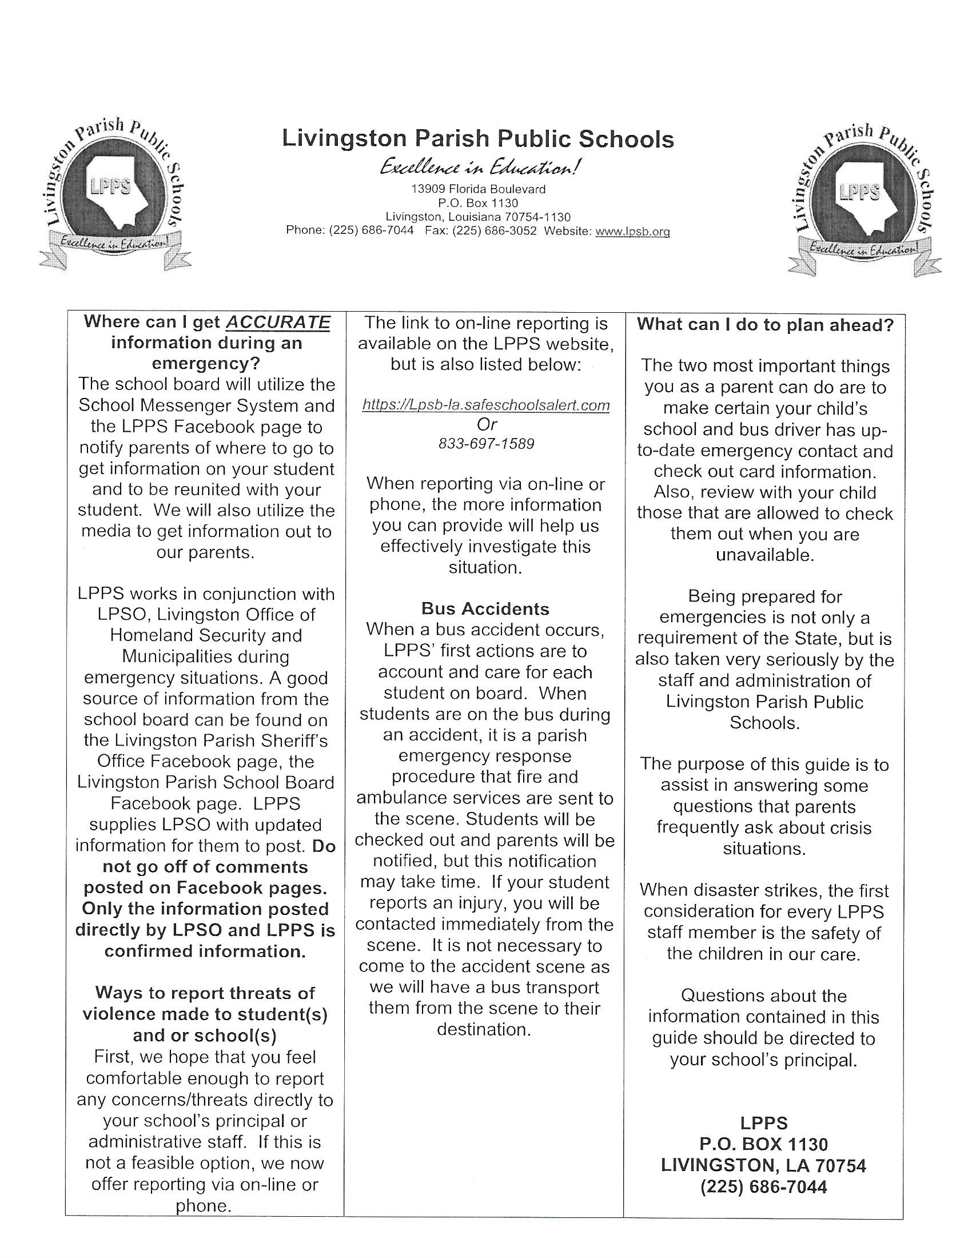

Livingston Parish Public School System
Livingston Parish Public School System
Title I Family Engagement Policy
2022-2023
A Districtwide Family Advisory Council has been established in order to revise the current Livingston Parish Title I Parent and Family Engagement policy and expand the plan in accordance with the Every Student Succeeds Act (ESSA) of 2015, section 1112 of the Elementary and Secondary Act (ESEA). This council will meet regularly in order to coordinate and integrate family involvement, and evaluate the effectiveness of the policy. This policy will be made available to the local community and updated periodically to meet the changing needs of the families and the school. The ultimate goal is to ensure that all families within the district are provided the same opportunities for involvement in their child’s education. The advisory council will also be informed of the process of the 1% of Title I, Part A funds reserved for family engagement. The Local Education Agency (LEA) will incorporate these ideas into the district-wide policy. If there are any unsatisfactory comments on the plan, these will be forwarded to the State Education Agency (SEA).
Under the direction and technical assistance of the Local Education Agency (LEA), each Title I school will have family members serve on the Schoolwide Committee, which will function to review the schoolwide plan and family activities for that school. This plan will be specific to the Title I school and will provide a means for families to become more involved in their child’s education.
Consistent with section 1118 of the ESEA, an annual meeting will be held in each school in which family members will be given information about their school participation in the Title I program and related services, an explanation of the requirements of this participation and a school/family compact as required by section 1118(d) of the ESEA. Family members will also be informed of their right to parent-teacher conferences, regular reports on their children’s progress, reasonable access to staff, opportunities to volunteer on campus, and to request information regarding the professional certifications of their student’s classroom teachers. To the extent, which is practical, meetings will provide full opportunities for the participation of family members of English Learners, Students with disabilities and migrant parents following section 1111 of the ESEA. Information will be understandable and uniform.
One goal of this plan will be to improve communication between home and school through family/school compacts, newsletters, family-teacher conferences, handbooks, agendas, surveys, School Messenger recordings. Electronic communications, such as: telephone calls, texts/emails, and various school social media formats of sharing information; such as Twitter, Facebook, Instagram and My School App. It is important that family members respond to communications from the school in a timely manner and talk with their children about their classroom activities and behavior.
Another goal will be to provide information concerning the Every Student Succeeds Act (ESSA) of 2015, the State of Louisiana Accountability Law, the curriculum used at the school, the forms of academic assessment used to measure student progress, and the proficiency levels students are expected to meet.
Title I schools will assist families with parenting skills, technology skills, and give assistance in helping with homework, projects, and other at-home activities. Families will be encouraged to take advantage of teacher conferences as a way of monitoring the progress of students. Schools will also provide opportunities for the local community to become more involved with families and with the school.
Family participation is essential to the success of the students. By monitoring the child’s progress and working with educators to improve students’ achievement, families provide a vital link between the school and the student. Students should know that their family values education and achievement and are available to help them to achieve their goals. Annually, each school will disseminate and collect family surveys to improve engagement. Results from the survey, if needed, will be used to revise family engagement policies at the school level.
It is Livingston Parish Public School System’s goal to reach out to, communicate with and work with families as equal partners in our schools.
Livingston Parish Public School System
Title I Family Engagement Policy
(Politica de Participación Familia)
2022-2023
Un Consejo Asesor Familia ha sido establecido por el distrito con el fin de revisar la actual política de Livingston Parish Title I Family Engagement (Participación de la Familia) y ampliar el plan de conformidad con el Every Student Succeds Act (ESSA) of 2015. Este Consejo se reunirá periódicamente con el fin de coordinar e integrar la participación de la familia y para evaluar la eficacia de la política. Esta política se pondrá a disposición de la comunidad local y será actualizada periódicamente para satisfacer las necesidades cambiantes de los padres y la escuela. El objetivo final es garantizar que todas las familias dentro del distrito sean proveídas de las mismas oportunidades de participación en la educación de sus hijos. El consejo asesor también será informado del proceso de los fondos del 1% del Título I, Parte A, Los Fondos Reservados para la Participación de los Padres-Familia. La LEA incorporara estas ideas dentro de la política de todo el distrito. Si hay algunos comentarios no satisfactorios en el plan, éstos se remitirán a la Agencia Estatal de Educación (State Education Agency/SEA, por sus siglas en ingles).
Bajo la dirección y la asistencia técnica de la Agencia Local de Educación, cada escuela Título I tendrá miembros de la familia sirviendo/ejerciendo en el Comité de la Escuela, que funcionará para revisar el plan de toda la escuela y las actividades de los padres de esa escuela. Este plan será específico a la escuela de Título I y proporcionará un medio para que padres-familia se involucren más en la educación de sus hijos.
Una reunión anual se llevará a cabo en cada escuela en la que se les dará a los padres información sobre la participación de su escuela en el programa Título I y los servicios relacionados, y una explicación de los requisitos de esta participación. Los miembros de la familia también serán informados de su derecho a las conferencias entre padres y maestros, informes periódicos sobre el progreso de sus hijos, el acceso razonable al personal, oportunidades para ser voluntario y participar en la clase de su hijo, y para solicitar información sobre los títulos profesionales de los maestros de sus hijos. En la medida de lo práctico, las reuniones de padres brindarán oportunidades para la participación de los miembros de la familia con inglés limitado, miembros de la familia con discapacidades y padres migrantes. La información será comprensible y uniforme. Uno de los objetivos de este plan será el de mejorar la comunicación entre el hogar y la escuela mediante acuerdos entre padres-familia/escuela, boletines informativos, conferencias entre padres y maestros, manuales, agendas, encuestas, mensajes vía School Messenger Phone System, comunicaciones electrónicas tales como: llamadas telefónicas, mensajes de texto y correos electrónicos y otros tipos de intercambio de información. Es importante que los padres respondan a las comunicaciones de la escuela de una manera oportuna y que hablen con sus hijos sobre sus actividades en el aula.
Otro objetivo será proporcionar información acerca del Every Student Succeeds Act (ESSA) of 2015, la Ley de Responsabilidad del Estado de Louisisana (State of Louisiana Accountability Law), el currículo usado en la escuela, las formas de evaluación académica utilizadas para medir el progreso del estudiante, y los niveles de competencia que se espera que los estudiantes cumplan.
Las escuelas Título I asistirán a las familias con las habilidades de crianza, habilidades tecnológicas, y darán asistencia para ayudar con las tareas, proyectos y otras actividades en el hogar. Los padres serán animados a tomar ventaja de las conferencias entre padres y maestros como una forma de monitorear el progreso de los estudiantes. Las escuelas también proporcionaran oportunidades para la comunidad local al involucrarse más con las familias y con la escuela.
La participación de familia es esencial para el éxito de los estudiantes. Al monitorear el progreso del niño/a y trabajar con los educadores para mejorar los logros de los estudiantes, los padres proporcionan un vínculo vital entre la escuela y el estudiante. Los estudiantes deben saber que sus de familia valoran la educación y los logros y están disponibles para ayudarles a alcanzar sus objetivos. Anualmente, cada escuela difundirá y recogerá encuestas de familia para aumentar la participación de la familia. Los resultados de la encuesta, si es necesario, se utilizarán para revisar las políticas de participación de familia en el ámbito escolar.
Es la meta del Sistema de Escuelas Públicas del Condado de Livingston (Livingston Parish Public School System) lograr comunicarse y trabajar con familias en condiciones de igualdad en las escuelas.

STUDENT INSURANCE
If you are interested in student insurance, please visit the following site:
https://www.bollingerschools.com/site/default.aspx

